------------------------------------------------------------------------------------------------------------------------------------------

Lab Assignment: 1

Full name: Gardyan Priangga Akbar

Student number: 7695883

Email address: [gardyanakbar99@gmail.com](mailto:gardyanakbar99@gmail.com)

------------------------------------------------------------------------------------------------------------------------------------------

**Flower Image Recognition by KNN, MLP and CNN**

This lab assignment aims to compare and analyze the various image classification approaches, namely KNN, MLP, and CNN. The dataset used for this assignment is a dataset consisting of over 4000 images of flowers spread across 5 different classification labels (daisy, dandelion, rose, sunflower, and tulip).

**KNN**

1. The python modules used for this task are as follows:

|  |  |
| --- | --- |
| Module | Usage |
| Pandas | To convert the resulting confusion matrix into a DataFrame alongside its proper labels |
| OpenCV | To load the flower images and generate the color histogram |
| NumPy | To convert the images into input for KNN |
| Matplotlib | To visualize the color histogram, images, and confusion matrix |
| Sklearn | To split the dataset into training, validation, and test sets, generate confusion matrix, and perform KNN |
| Seaborn | To generate a heatmap of the confusion matrix |
| os | To get list of files from a directory |
| time | To track the time taken to evaluate the test set |

1. I created a list of k to test and then compare them to see which one has the highest accuracy on the validation dataset. Plotting the results visualizes where the value of k is best.   
   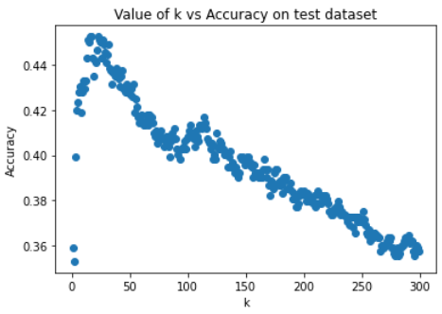  
   I did not go beyond 300 for the value of k as the accuracy seem to continue going downhill as shown by the graph. By further utilizing Python’s max() and index() functions I was able to determine the best value for k is 16, with it having the highest accuracy score of 0.4525462962962963 on the validation dataset.
2. The classification accuracy of the KNN model on the test set was 0.41087962962962965.  
   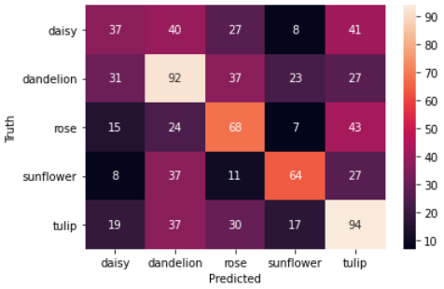  
   According to the confusion matrix, the model struggles the most in classifying roses as tulips.
3. It took 0.09799885749816895 seconds for the KNN classifier to classify all the samples in the test set.

**MLP**

1. I use the MLPClassifier class provided by sklearn library to create the MLP models. I can specify the number of hidden layers and the number of neurons in each hidden layers through the class’ constructor by specifying the hidden_layer_sizes property. For example, if I wanted to have 3 hidden layers with 512 neurons each I would pass in the value [512, 512, 512] into that attribute. I then utilized the fit() method from the MLPClassifier class to train the model and its predict() method to make predictions on the test set.
2. The 9 MLP structures I designed have different amounts of layers and neurons in each layers following the requirements specified in the instructions document. Implementing them is simply creating a list of the number of layers (1 to 3) and another list containing the number of neurons. I then iterate through both lists using a nested for loop, all the while creating a new MLPClassifier object at every iteration.
3. To find which of the nine models was the best, I used the score() method that comes with the MLPClassifier class on the validation set that would return the accuracy score. The results are graphed below:  
   Chart, bar chart

   Description automatically generated  
   By utilizing Python’s built-in max() and index() functions I can get the best model to be the MLP with 2 layers at 512 neurons in each layer.